ED KIIRU

MORTGAGE R1:SP3:STORY 5

Created the ODS_Morgage Database

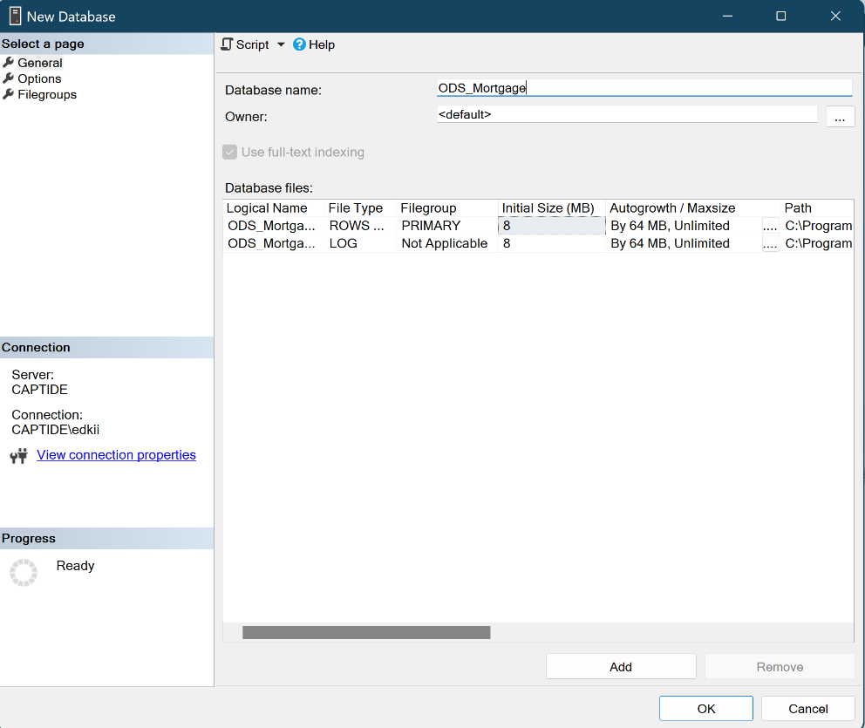

Created the RMG Final table

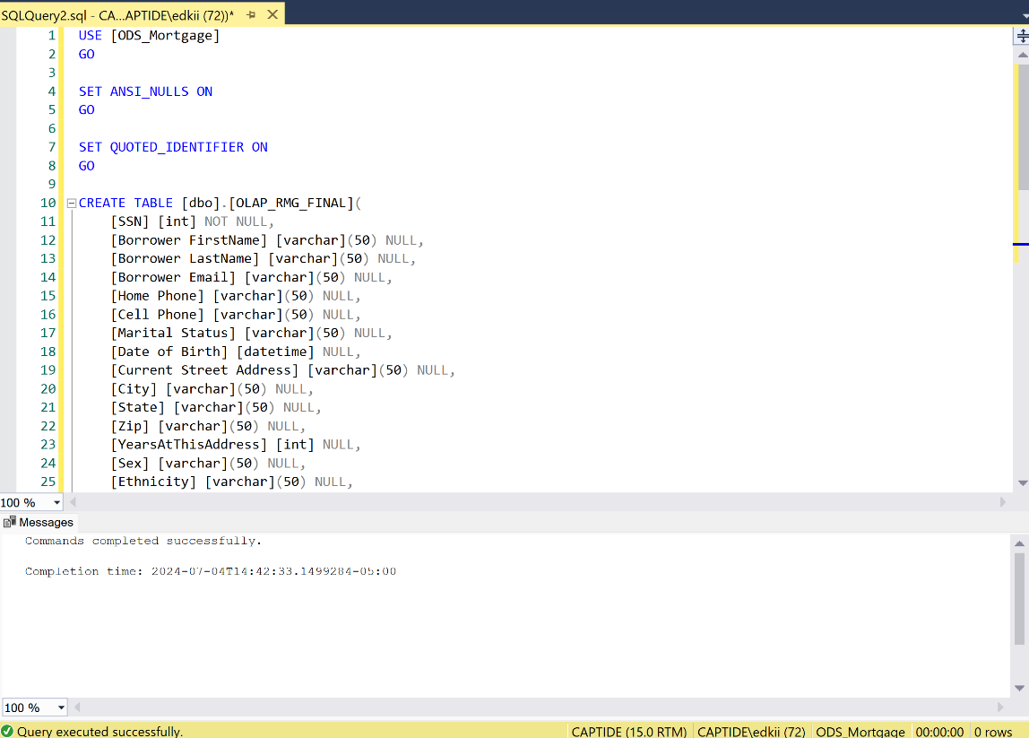

**Added an Execute SQL task to truncate the destination table and a dataflow task to work the transformations**

**Configured the Execute SQL task**

**Created both the source and destination connection managers**

**Configured the destination manager**

**Executed the Package**

**Package run Successfully**

**New data added to the ODS_Morgage database**

